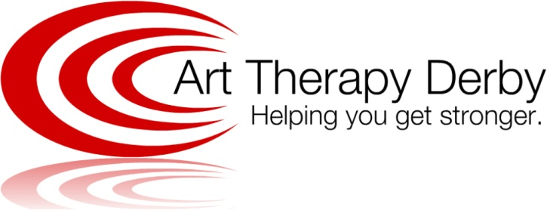
Marta Perestrello
martaperestrello@arttherapyderby.com
16a Uttoxeter Road
Foxglove Yard
Derby
DE3 0DA
07707 097 713
www.arttherapyderby.com

Art Therapy Derby

Services and Fees

(for children and young people in Local Authority Care)

2022

Art Therapy Work £58.00 per week
This work involves face-to-face or online weekly individual sessions with the child or young person only. Any work, such as a written report or attendance of meeting, needed will be charged individually as and when requested.

Package Referral £116.00
This Referral Package includes an Introductory Meeting with the referral (home manager, key carer and/or social worker) to discuss the referral, history and current situation of the young person being referred to Art Therapy Derby. This fee, also takes into account the reading of the young person’s file submitted with Referral, which should include the young person’s all relevant documents to referral such as chronology and history, therapy or any other psychology reports, Care Plan and latest LAC report.

Art Therapy Package £116.00 per week
This is particularly relevant to children or young people in LA residential care, or when there are a wider number of professionals involved in their care.
· A weekly 60 minutes art therapy session with the young person
· Regular phone contact to care staff or home manager at the residential home for staff support/consultation, feedback and updates on the child/young person’s progress and significant events as and when needed
· Monthly invoice

Care Staff Team Consultation £116.00 + travelling expenses (45p per mile away from Art Therapy Derby)
I offer regular fortnightly care staff consultation. When working with individuals who suffered abuse, neglect or trauma, it is particularly important to secure trauma informed reflective practice. Staff consultation meetings offer the time and frame to support reflection and discussion on the child or young person's presentation, behaviour, and progress as well as the dynamics amongst the group living. It is through this shared reflection that staff can better understand all the children and young people that they work with in the care home and with this better plan their work to meet the young people’s needs. This work also consolidates staff consistency and empowers members in their work and relationships with the children and young people; potentially preventing staff burnout and reducing turnover.

Managerial/Senior/Individual Care Staff Consultation £58.00 per hour + travelling expenses (45p per mile away from Art Therapy Derby)
This consultation is to support care home managers, senior and or key worker staff members. The groups are smaller and consultation is more specific to group/staff dynamics or specific to the impact of one particular young person in the home. This consultation is helpful to be alternated with Care Staff Team Consultation to support home managers and senior staff in understanding group living dynamics as well as to plan and support not only their young people but also the care staff therapeutic work.

Parental/Key Carer Consultation £58.00 per 60 minutes (booked as and when needed)
Working with children and young people, gives me a good insight of their internal world, personal circumstances and relationship dynamics. Without ever compromising my confidentiality agreement with the child or young person, parental or key carer consultation can further support the child or young person’s external network. In consultation, I offer understanding, psychoeducation and strategies to parents and other professionals to support the child’s therapy work as well as to strengthen family relationships and dynamics.

Professionals and Strategy Meetings £58.00 per hour + travelling expenses (45p per mile away from Art Therapy Derby)
When working with children and young people in care, communication is paramount. Professionals may need to meet following serious incidents or concerns about a particular individual to evaluate and adapt current interventions as well as discuss and plan future ones. As the child or young person's therapist I can contribute to team discussions and help staff to plan their care, with the insight into the child's inner world and needs. My contribution can help other professionals consider the young person's therapeutic progress and plan and implement strategies.

LAC and Care Team Meetings £58.00 per hour + travelling expenses (45p per mile away from Art Therapy Derby)

LAC Report Writing (£170.00)
These are important meetings in the child or young person's life in LA care. As their therapist, I contribute to professional discussions, providing an updated written report to share the child or young person's progress in therapy, making recommendations for the following reviewing period.

Training £500.00 for 3 hours up to 10 participants + travelling expenses (45p per mile away from Art Therapy Derby)
I offer half day (3 hours) CPD training for children's residential care staff on:
· Child brain development and impact of trauma; an introduction
· Understanding stress and trauma and its responses in children and young people
· Understanding attachment development in care; an introduction
· Self-care and vicarious trauma; supporting staff working with trauma

Please note that I reserve the right to review services and fees in January of each year. All the services are provided with the child and young person's best interest in mind; this is continuously reviewed and when necessary, services adjusted to meet their needs. If changes are to be made you would be consulted, informed and made aware with sufficient time in advance.

